Project 2: Final Project Proposal

By:

Claudia Tchokouani

SDEV 385 - 6381: Principles of Web Design

Professor Leslie Allen

October 29, 2023

***Client and Topic***

The website will be for a client. This person owns a small business creating natural products by hand. The main aspect of her small business is creating custom jewelry using natural mineral stones.

***Development Process and Engagement***

The client is considerably the most integral part of developing an application. Determining everything from minute details of button placement and all the way up to marketing, is all contingent on the needs of and available content the client has to offer. The client will need to provide:

1. Company information, i.e., company name, founder, product information etc.
2. Are they the owner, cofounder, employee etc.
3. How do they see the website developing? What does expansion look like?
4. What public information would they like displayed
5. Who is their target audience? Do they have a specific demographic they would like to focus on?
6. How is the market and what is the demand for their product?
7. Are there similar businesses and products on the market and what do their websites look like?
8. Do they have any websites they like?
9. Do they have social media?

***Testing***

There are many tests that must be done prior to launching a website. A few tests I would be conducting are:

1. The visual layouts such as my alignments, margins and paddings
2. Waiting for pages to finish loading to ensure all images load properly.
3. Time how long a page takes to load on the browser.

I would also test on different browsers to ensure all features work the same. The main browsers to test on are Edge, Chrome, Firefox and Safari.

***Description***

The goal of the business is to manufacture natural products such as custom jewelry, butters and hair care products to customers around the world. They want to be able to stay up to date and keep their customers up to date about business products.

The website will certainly be optimal in meeting the customer’s goals. Since the web allows access to information globally, shoppers with internet access can view her products anywhere around the world. This will expand her marketing reach, thus increasing the possibility of growing her customer base.

The client’s main target audience at this time are those of lower to middle class females ranging from age 15 – 60 years old.

Identifying the target audience will help determine color choices, font and even how the product is presented on screen.

One unique touch I would like to present on the screen is a flower petal following slowly from top to bottom of the page every X number of minutes.

Contents I will be using from other sites are images of mineral rocks taken from stock photos or google.

The Website’s content will be updated on a quarterly basis.

***Growth and Maintenance***

Overtime, the website will evolve to include different payment options, such as Apple Pay and PayPal. There will be a database to store customer data.

Tasks I will do to maintain the website are ensuring there are no broken links. Adding new products to the page. Make sure product availability is up to date.

These tasks will most likely occur once a week.

***Organization***

The website content will be organized with stack effect. 50px left and right margins, a centered look and no side navigation. Soft floral colors for the home page and a white background for the proceeding pages.

Subtopics will be BYO (Buil Your Own) and Products listed under the SHOP navigation link

Pages Included on the website are:

1. HOME
2. SHOP
   1. BYO
   2. PRODUCTS
3. ABOUT

The page layout will be a single column page with top navigation. The client wants a very simple clean look, almost similar to a mobile site.She wants visitors to easily navigate the website. Side navigation makes the page look slightly cumbersome.

1. Index.hmtl

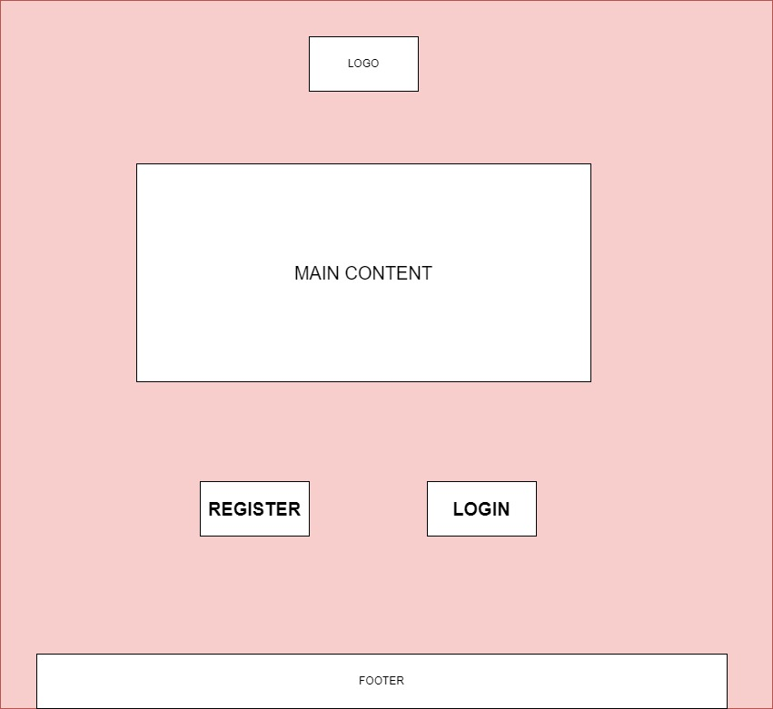

1. Build Your Own page

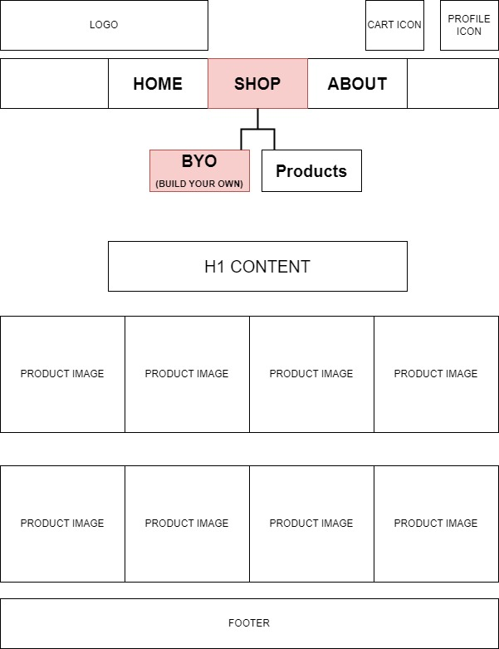

1. Products Page

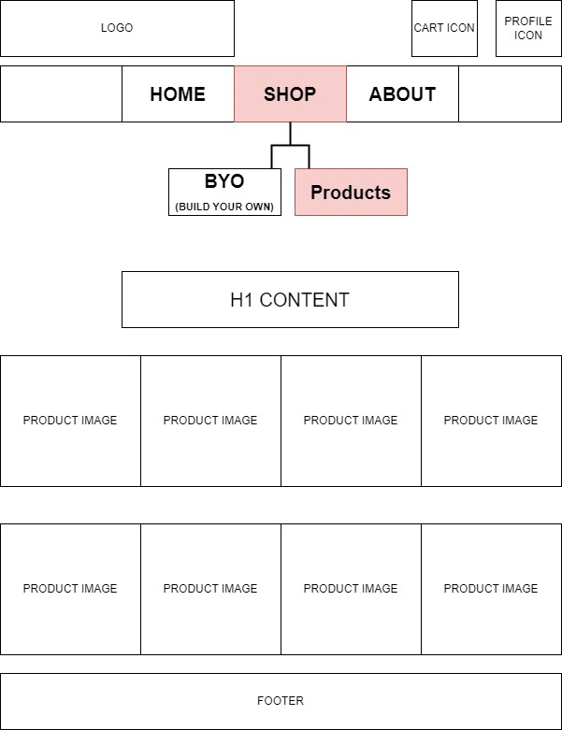

1. About page

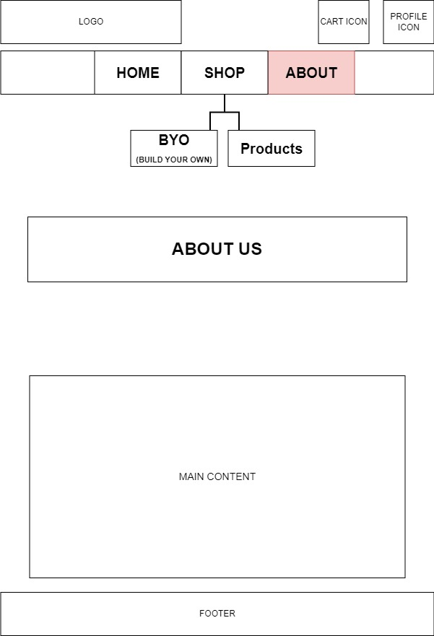

1. Flowchart

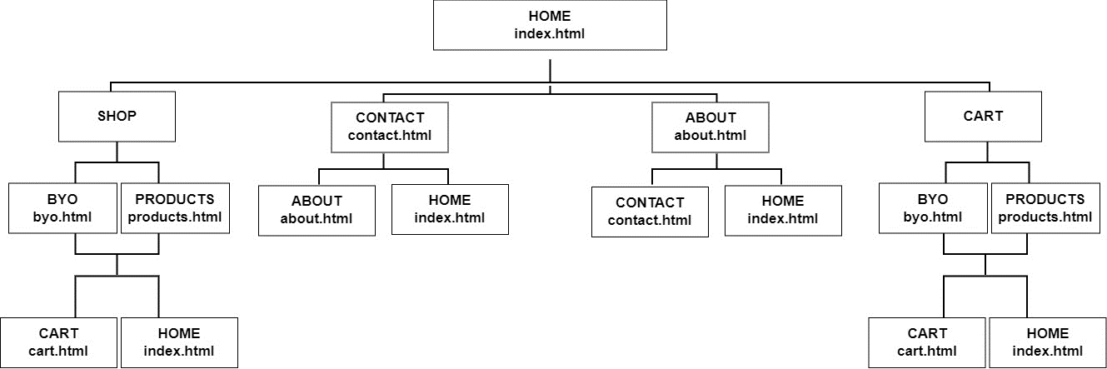

***Web Hosting***

Before considering a we host, I will first take these into consideration

* 1. Are there servers up 24/7 and how often do they go down?
  2. Are there multiple streams of contact and is documentation for common issues easily accessible?
  3. Do the servers have enough space to accommodate the growing website?
  4. Can they withstand heavy traffic to the website?
  5. Are there different options for domain name purchase?
  6. Is the price justifiable?

Technologies necessary for the functionality of the website

1. Shopping cart
2. Database

JavaScript would be used to dynamically update products and customer information.

The domain name I selected was angelste.com because it is easy to remember while still making the business name obvious.

***Marketing***

The website would be marketed through social media, email, flyers and word of mouth.

SEO (Search Engine Optimization) elements that can be covered in the planning and building process are

1. Keeping the website interesting with content visitors want to see
2. Usable navigation making it a comfortable experience for visitors
3. it mobile-friendly

***Security***

The website will have an ecommerce an ecommerce component.

User accounts will be password protected to protect visitor data such address, cards and other personal information

It is not obligated for the user to create an account, but it is more beneficial If they do.

Steps I could take to secure the website are:

1. No sensitive data in the URL
2. Enforce usage policies
3. Delete prior form inputs
4. Hash passwords

References:

Mozilla (n/a) *Security on the Web* Retrieved October 21, 2023

From <https://developer.mozilla.org/en-US/docs/Web/Security>

McDonald, M (June 2020) *Web Security for Developers* Retrieved October 21, 2023

From <https://learning.oreilly.com/library/view/the-principles-of/9781457174353/Text/ch01.html?sso_link=yes&sso_link_from=umgc>

Duffy, M. (2015) *Sams Teach Yourself HTML, CSS and JavaScript*  Retrieved October 23, 2023

From <https://www.simform.com/blog/devops-automation/>